The software is supposed to handle student record information.It is suppose to track the students attendance, scores and information
- Vision
- Organization
THe organzation is charge of this will be the Administation department of the school.The reason they are the organization is because even though the service will be used by the school it will be mainly handled by the administation

- Boss
The boss of the system will be the head administrator as they would be in charge of the Administration department

- Vision
Shorten the cycle when looking up a students info from the many minutes needed to find files to the seconds
Create a backup ability for student informationr

- Business modeling
- Business use case diagram

- To find an organization to improve through experiment.
Organization: Administration Department of the school
Boss: Head administratior
The department is in charge of the students records

- To identify business actor, business worker and business entity through experiment.
Business Actor
Actor | Description
Parents | Seeks their wards information
Employers | Seeks a potential employees school records
Student | Seeks their records
Other Schools | Seeks student record in the situation the student graduates or transfers

Business Worker
Worker | Description
Teacher | Seeks or updates students information
Administrator | Seeks or updates students information

Business Entities
Entities | Description
Student Record System | Central database for student records

- To identify business use case through experiment.
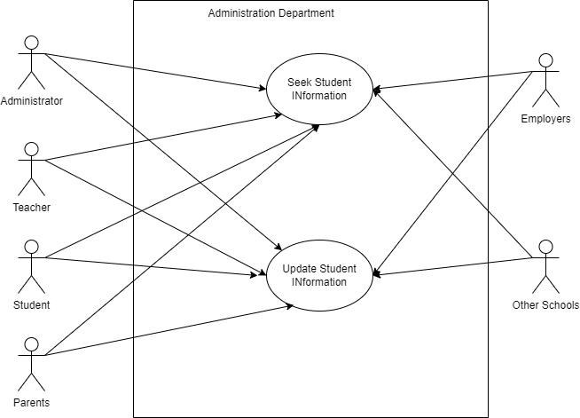

- Business sequence diagram(before improvement)
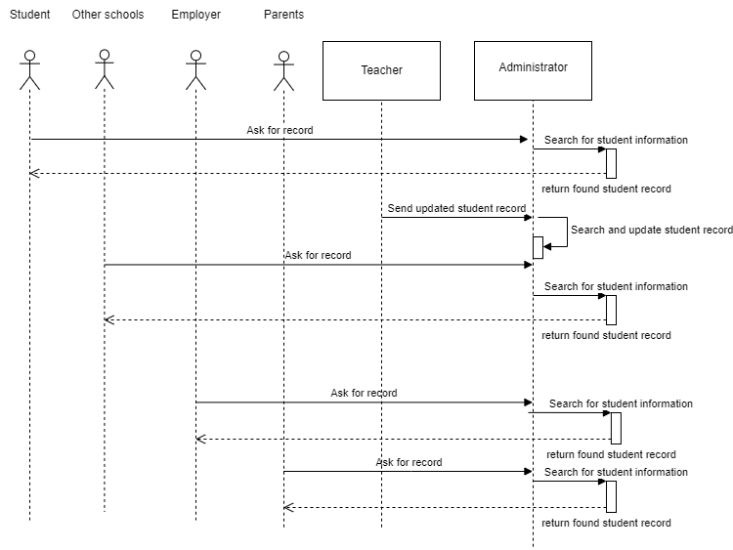

- Business sequence diagram(after improvement)
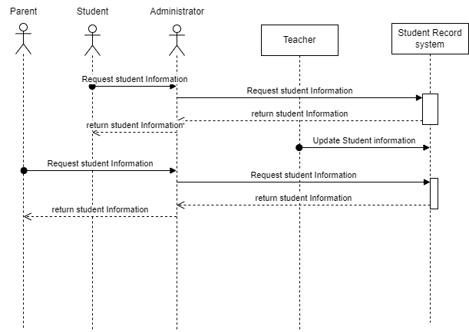

- Requirements
- System use case diagram
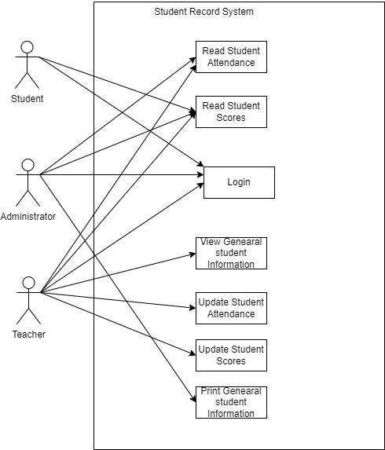
- Specification

Identified Functional Requirements
- Allow Student,Administator and Teacher to login
- Administrator can view student information, print student information,view score and view attendance
- Teachers can view student information,View scores and attendance and update scores

Identified Non-Functional Requirements
- Must have a fast response time-Query should respond within 2 seconds
- Only logged in users must access the system
- Ensure data security and privacy — encryption algorithms
- Reliable and scalable — system should run smoothly 24/7 with 99.9% uptime

- Login

use case ID:UC01
use case name: login
actor: Student/Administrator/Teacher
precondition: none
post condition: Student/Administrator/Teacher has logged in.
Basic path:
1.System requests to login.
2. System responds an interface to login.
3. Student/Administrator/Teacher submits login information.
4. System validate information to login
5. System responds a successful interface to login.

Extended path:
3a. System will display "ID and password cannot be empty" if the Student/Administrator/Teacher does not enter the ID and password.
3b. System will display "ID or password is incorrect, please renter" if the ID and password is entered incorrectly.
5a. System responds a failure interface to login

use case ID:UC02
use case name: Update Records
actor:Teacher
precondition: Must have logged in
post condition:Updated Student record.
Basic path:
1.System request for student credentials
2.Teacher submits the student credentials
3.System responds to an interface to validate student credentials
4.Teacher requests to update student record.
5. System responds an interface to update student records.
6. Teacher submits updated student records information.
7. System validate information to update student records
8. System responds a successful interface to update student records.

Extended path:
3a. i. System will display "Student cannot be found" if the Student credentials does not match any available student.
3a. ii. System will display "Invalid entry" if information is entered incorrectly.
7a. System responds a failure interface to update student records

use case ID:UC03
use case name: View Records
actor:Student/Administrator/Teacher
precondition: Must have logged in
post condition:View Student record.
Basic path:
1.System request for student credentials
2.Student/Administrator/Teacher submits the student credentials
3.System responds to an interface to validate student credentials
4.Student/Administrator/Teacher requests to view student record.
5. System responds an interface to view student records.

Extended path:
3a. i. System will display "Student cannot be found" if the Student credentials does not match any available student.
3a. ii. System will display "Invalid entry" if information is entered incorrectly.
5a. System responds a failure interface to view student records

- Analysis
- Find object and class
(1)login
use case ID:UC01
use case name: login
actor: Student/Administrator/Teacher
precondition: none
post condition: Student/Administrator/Teacher has logged in.
Basic path:
1.System requests to login.
2. System responds an interface to login.
3. Student/Administrator/Teacher submits login information.
4. System validate information to login
5. System responds a successful interface to login.

Extended path:
3a. System will display "ID and password cannot be empty" if the Student/Administrator/Teacher does not enter the ID and password.
3b. System will display "ID or password is incorrect, please renter" if the ID and password is entered incorrectly.
5a. System responds a failure interface to login

Analyze:
System is noun and ID and password are attribute for login the Student/Administrator/Teacher, So delete the system, an interface to login, information to login.

After analysis we get objects: Student/Administrator/Teacher, an interface to login, successful interface to login, failure interface to login

We get from interface from 1st step in basic path, name it index interface.
Now we classify these objects to get
Classes: Student/Administrator/Teacher,InterfacetoLogin,SuccessfuIinterfacetoLogin,Index, FailureInterfacetoLogin.

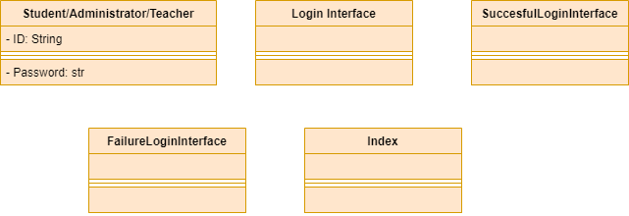

use case ID:UC02
use case name: Update Records
actor:Teacher
precondition: Must have logged in
post condition:Updated Student record.
Basic path:
1.System request for student credentials
2.Teacher submits the student credentials
3.System responds to an interface to validate student credentials
4.Teacher requests to update student record.
5. System responds an interface to update student records.
6. Teacher submits updated student records information.
7. System validate information to update student records
8. System responds a successful interface to update student records.

Extended path:
3a. i. System will display "Student cannot be found" if the Student credentials does not match any available student.
3a. ii. System will display "Invalid entry" if information is entered incorrectly.
7a. System responds a failure interface to update student records

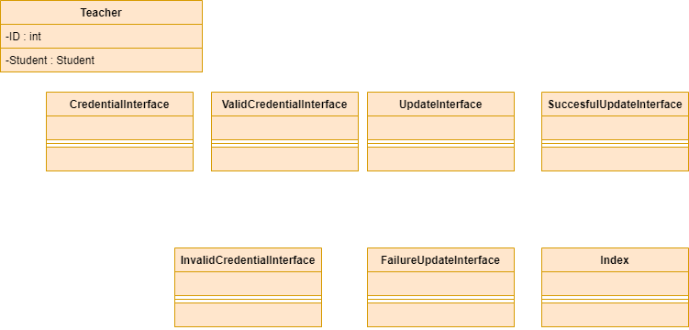

use case ID:UC03
use case name: View Records
actor:Student/Administrator/Teacher
precondition: Must have logged in
post condition:View Student record.
Basic path:
1.System request for student credentials
2.Student/Administrator/Teacher submits the student credentials
3.System responds to an interface to validate student credentials
4.Student/Administrator/Teacher requests to view student record.
5. System responds an interface to view student records.

Extended path:
3a. i. System will display "Student cannot be found" if the Student credentials does not match any available student.
3a. ii. System will display "Invalid entry" if information is entered incorrectly.
5a. System responds a failure interface to view student records

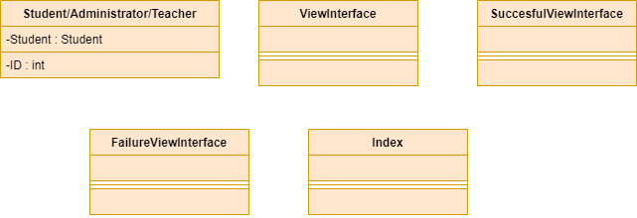

- Domain class digram(using four color pattern)
- login
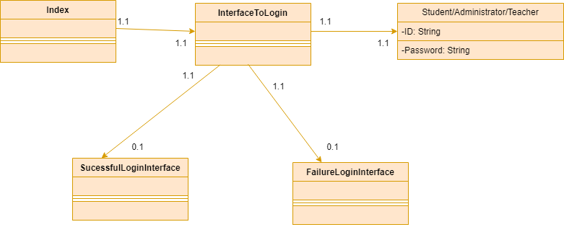

2) Update Student

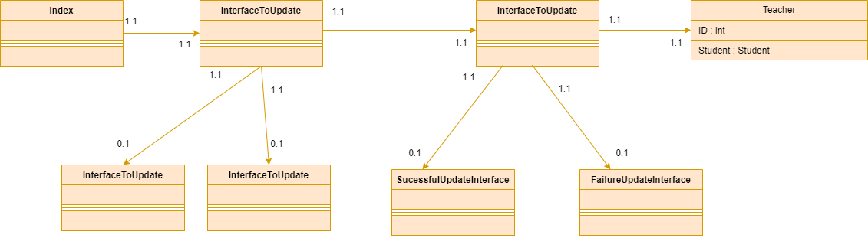

3)View Student Records
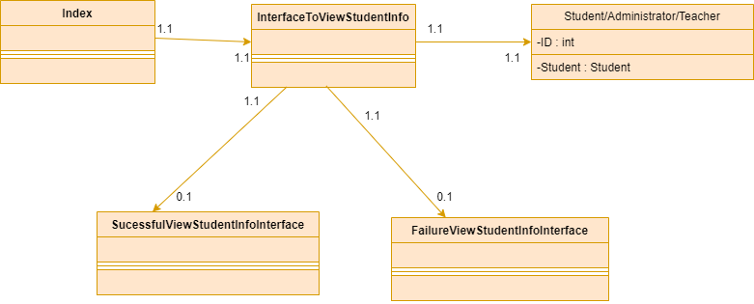

- Statechart diagram
(1)login
use case ID:UC01
use case name: login
actor: Waiter
precondition: none
post condition: waiter has logon.
Basic path:
- Waiter requests to login.
- System responds an interface to login.
- Waiter submits login information.
- System validate information to login.
System responds a successful interface to login.

Extended path:
3a. System will display "employID and password cannot be empty" if the waiter does not enter the employID and password.
3b. System will display "employID or password is incorrect, please renter" if the employID and password is entered incorrectly.
5a. System responds a failure interface to login
Field Set:
waiter=employID+password
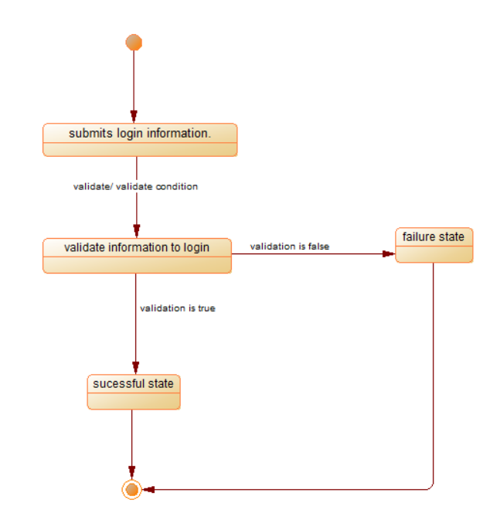

use case ID:UC01
use case name: login
actor: Student/Administrator/Teacher
precondition: none
post condition: Student/Administrator/Teacher has logged in.
Basic path:
1.System requests to login.
2. System responds an interface to login.
3. Student/Administrator/Teacher submits login information.
4. System validate information to login
5. System responds a successful interface to login.

Extended path:
3a. System will display "ID and password cannot be empty" if the Student/Administrator/Teacher does not enter the ID and password.
3b. System will display "ID or password is incorrect, please renter" if the ID and password is entered incorrectly.
5a. System responds a failure interface to login

Analyze:
System is noun and ID and password are attribute for login the Student/Administrator/Teacher, So delete the system, an interface to login, information to login.

After analysis we get objects: Student/Administrator/Teacher, an interface to login, successful interface to login, failure interface to login

We get from interface from 1st step in basic path, name it index interface.
Now we classify these objects to get
Classes: Student/Administrator/Teacher,InterfacetoLogin,SuccessfuIinterfacetoLogin,Index, FailureInterfacetoLogin.

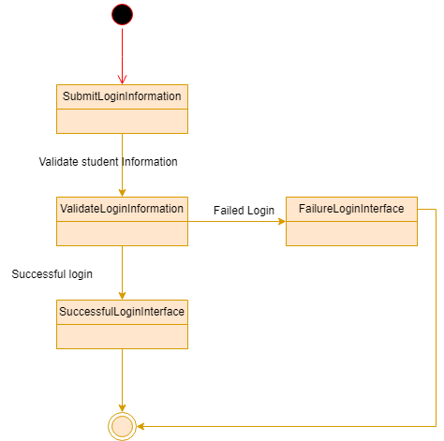

use case ID:UC02
use case name: Update Records
actor:Teacher
precondition: Must have logged in
post condition:Updated Student record.
Basic path:
1.System request for student credentials
2.Teacher submits the student credentials
3.System responds to an interface to validate student credentials
4.Teacher requests to update student record.
5. System responds an interface to update student records.
6. Teacher submits updated student records information.
7. System validate information to update student records
8. System responds a successful interface to update student records.

Extended path:
3a. i. System will display "Student cannot be found" if the Student credentials does not match any available student.
3a. ii. System will display "Invalid entry" if information is entered incorrectly.
7a. System responds a failure interface to update student records

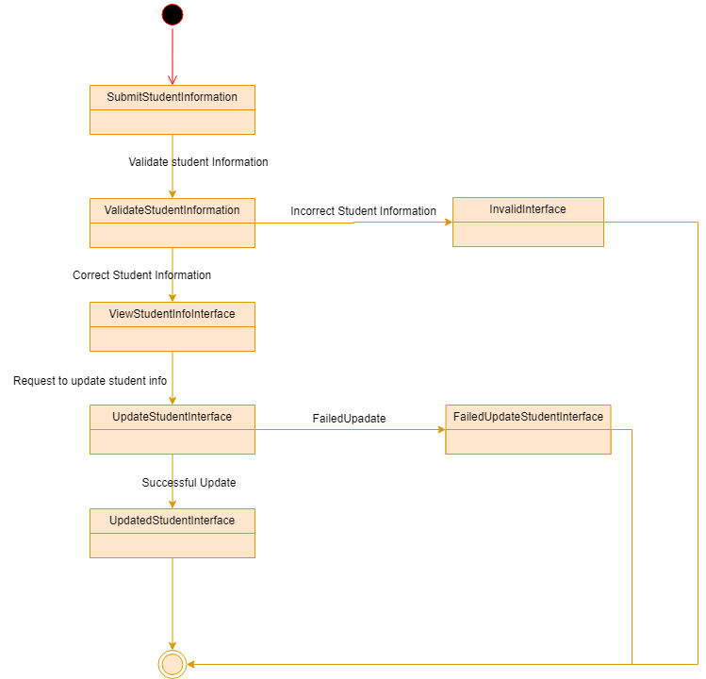

use case ID:UC03
use case name: View Records
actor:Student/Administrator/Teacher
precondition: Must have logged in
post condition:View Student record.
Basic path:
1.System request for student credentials
2.Student/Administrator/Teacher submits the student credentials
3.System responds to an interface to validate student credentials
4.Student/Administrator/Teacher requests to view student record.
5. System responds an interface to view student records.

Extended path:
3a. i. System will display "Student cannot be found" if the Student credentials does not match any available student.
3a. ii. System will display "Invalid entry" if information is entered incorrectly.
5a. System responds a failure interface to view student records

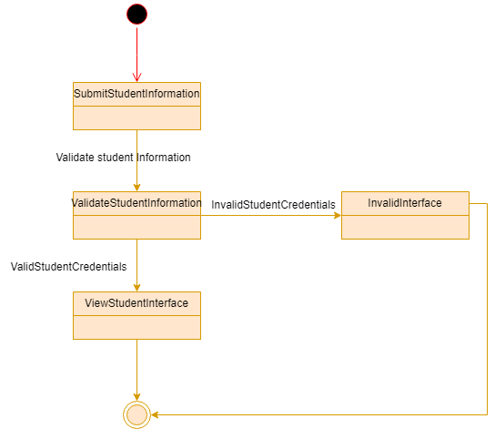

(2)Sequence diagram

(1) login
Basic path:
1.System requests to login.
2. System responds an interface to login.
3. Waiter submits login information.
4. System validate information to login.
5. System responds a successful interface to login.

Extended path:
3a. System will display "employID and password cannot be empty" if the waiter does not enter the employID and password.
3b. System will display "employID or password is incorrect, please renter" if the employID and password is entered incorrectly.
5a. System responds a failure interface to login

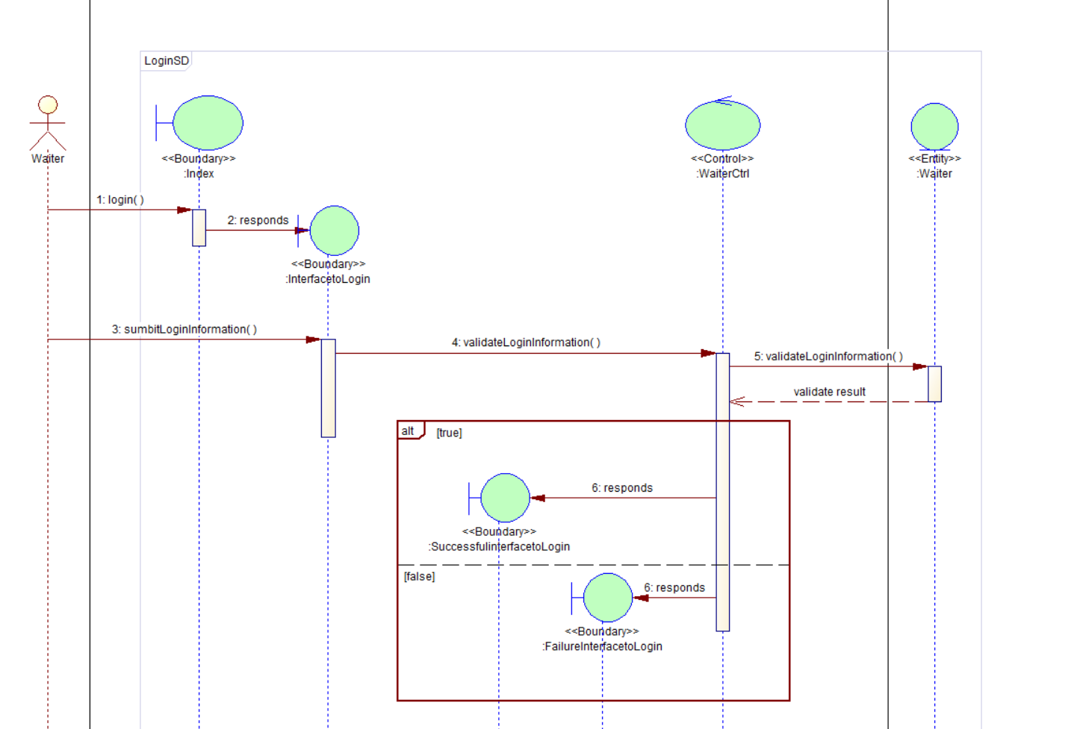

login
use case ID:UC01
use case name: login
actor: Student/Administrator/Teacher
precondition: none
post condition: Student/Administrator/Teacher has logged in.
Basic path:
1.System requests to login.
2. System responds an interface to login.
3. Student/Administrator/Teacher submits login information.
4. System validate information to login
5. System responds a successful interface to login.

Extended path:
3a. System will display "ID and password cannot be empty" if the Student/Administrator/Teacher does not enter the ID and password.
3b. System will display "ID or password is incorrect, please renter" if the ID and password is entered incorrectly.
5a. System responds a failure interface to login

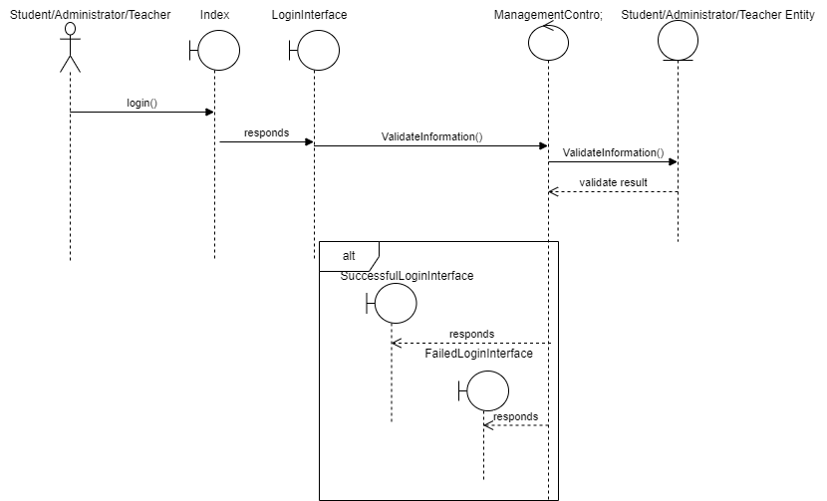

2.use case ID:UC02
use case name: Update Records
actor:Teacher
precondition: Must have logged in
post condition:Updated Student record.
Basic path:
1.System request for student credentials
2.Teacher submits the student credentials
3.System responds to an interface to validate student credentials
4.Teacher requests to update student record.
5. System responds an interface to update student records.
6. Teacher submits updated student records information.
7. System validate information to update student records
8. System responds a successful interface to update student records.

Extended path:
3a. i. System will display "Student cannot be found" if the Student credentials does not match any available student.
3a. ii. System will display "Invalid entry" if information is entered incorrectly.
7a. System responds a failure interface to update student records

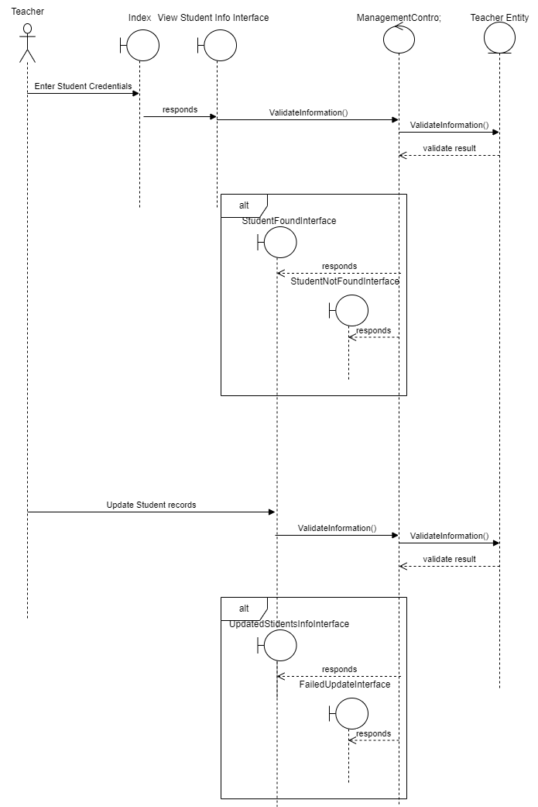

3.
use case ID:UC03
use case name: View Records
actor:Student/Administrator/Teacher
precondition: Must have logged in
post condition:View Student record.
Basic path:
1.System request for student credentials
2.Student/Administrator/Teacher submits the student credentials
3.System responds to an interface to validate student credentials
4.Student/Administrator/Teacher requests to view student record.
5. System responds an interface to view student records.

Extended path:
3a. i. System will display "Student cannot be found" if the Student credentials does not match any available student.
3a. ii. System will display "Invalid entry" if information is entered incorrectly.
5a. System responds a failure interface to view student records
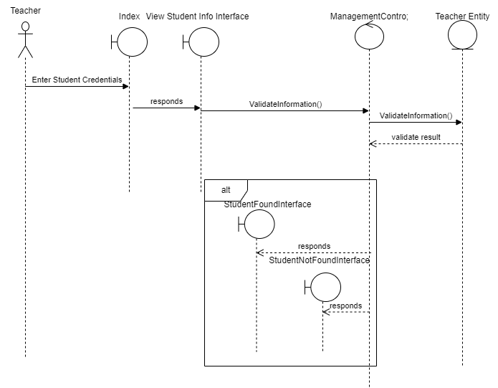

- Class diagram

(1)login
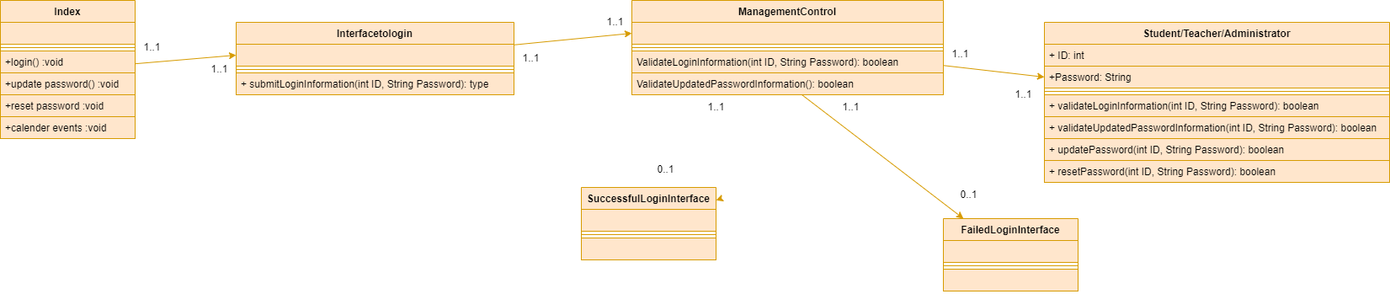

2)Update Records
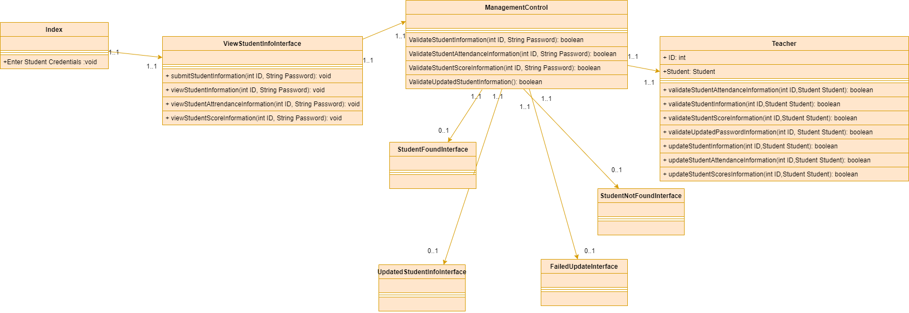
3) View Student Records
